Supply Brain
SKU Segmentation — Business Rationale & Feature Engineering
Annual, whole-history clustering · 500 SKUs · k = 3 (silhouette-selected)
Prepared as supporting documentation for the Capstone segmentation module

1. Executive Summary
The segmentation groups the 500-SKU catalog into three statistically distinct, business-interpretable segments using ten engineered features spanning demand behavior, supply reliability, network lead time, pricing, and financial performance. The clustering is not a cosmetic label — four of the ten features are statistically significant drivers of the split (ANOVA p < 0.001), and the resulting segments map cleanly onto three different supply-chain postures a planner would actually manage differently.
Cluster | SKUs | % of Catalog | % of Revenue | % of Margin | Avg Stockout Rate | Avg Lead Time (days)
High-Revenue / Low-Margin / Stable-Demand | 25 | 5.0% | 50.6% | 52.1% | 1.4% | 4.3
High-Margin / Volatile / Slow-Replenish | 119 | 23.8% | 13.7% | 13.7% | 3.8% | 6.2
Stockout-Risk | 356 | 71.2% | 35.6% | 34.3% | 4.3% | 4.1

Headline finding: just 5% of the catalog (25 SKUs) generates just over half of all revenue and margin. This is a textbook Pareto concentration, and it is the single most important fact in the segmentation for prioritizing planning effort.

2. Methodology Overview
The pipeline runs in three stages, all on whole-history (annual, non-seasonal) data so that each SKU is described once by its full-year behavior:
- Feature engineering — six independent tables are built directly from the raw operational data (demand forecasts, orders, production, inventory, and the physical distribution network), each computing one family of SKU-level metrics.
- Standardization & clustering — the ten features used for clustering are combined into one matrix, missing values are filled with the column median (affects 1 of 500 SKUs, for lead time only — see §5), scaled with a z-score (StandardScaler), and clustered with k-means. k is chosen automatically by the highest silhouette score across k = 2–8, with a rule that k = 2 is only accepted if it wins by a wide margin — otherwise the model prefers at least 3 segments, since 2 is too coarse a foundation for differentiated inventory policy. Here k = 3 won on both counts: it had the single highest silhouette score (0.198) and did not need the floor rule.
- Validation & naming — cluster separation is checked with a one-way ANOVA per feature (is this feature actually different across clusters, or is the split arbitrary?), and each cluster is given a business name automatically from rules applied to its feature averages, not typed in by hand — for example, a cluster only earns the “High-Revenue” tag if its share of total revenue is at least double its share of the catalog.

3. Feature Engineering: What Each Feature Measures, and Its Statistical Role
Ten features were computed and fed into the clustering. The table below ranks them by ANOVA F-statistic — how strongly each one actually separates the three clusters — from the raw feature matrix output.
Feature | F-stat | p-value | Significant?
lead_time_std_days | 1,539.7 | < 0.001 | Yes
list_price_usd | 352.2 | < 0.001 | Yes
lead_time_mean_days | 236.6 | < 0.001 | Yes
revenue_total | 128.4 | < 0.001 | Yes
stockout_rate | 2.81 | 0.061 | No (borderline)
demand_cv | 2.68 | 0.069 | No (borderline)
supply_adherence_std | 2.44 | 0.088 | No
forecast_mape | 0.33 | 0.719 | No
shelf_life_days | 0.15 | 0.864 | No
margin_pct | 0.07 | 0.936 | No

Reading this table: the clustering is really being driven by two things — how volatile and slow a SKU's replenishment path is (the two lead-time features plus, indirectly, the adherence/stockout features that ride along with it), and how commercially important the SKU is (price and revenue). The bottom six features are statistically flat across clusters — they still describe each SKU individually and are useful for profiling and downstream policy, but they are not what separates the three groups. This is a healthy result: it means the segmentation is anchored to two clear, independent business axes rather than to noise.

3.1 Demand & Forecast Features
demand_mean, demand_std, demand_cv
Source: demand_forecast.csv, filtered to horizon = “in_sample” (i.e., weeks where an actual outcome exists, not the forward-looking forecast rows). Computed per SKU across all in-sample weeks: demand_mean and demand_std are the mean and standard deviation of actual_qty; demand_cv (coefficient of variation) is demand_std ÷ demand_mean.
Business role: demand_cv is the standard “how lumpy is this SKU’s demand” metric — a CV near 0 means steady, forecastable demand; a high CV means spiky, promotion- or seasonality-driven demand that needs bigger safety buffers. It was not a significant separator here (p = 0.069) because demand volatility turned out to be fairly uniform across the catalog (0.81–0.92 average CV in every cluster) — the segments differ far more on how hard the SKU is to replenish than on how erratic its demand is.
forecast_mape
Source: same demand_forecast.csv in-sample rows; mean of the absolute value of forecast_error_pct per SKU. This is the classic Mean Absolute Percentage Error — on average, how far off was the forecast from the actual, as a percentage.
Business role: flags SKUs the current forecasting process struggles with, independent of how volatile the underlying demand is. Not a cluster driver (p = 0.72), so forecast accuracy is roughly consistent across segments — worth tracking per-SKU regardless, but it is not what makes these three groups different.

3.2 Inventory Health
stockout_rate
Source: inventory.csv. stockout_weeks counts every (SKU, DC, week) row where closing_stock = 0; total_weeks counts every (SKU, DC, week) row that exists for that SKU. stockout_rate = stockout_weeks ÷ total_weeks. Note this is a row-level rate across all DC/week combinations a SKU is stocked in — not a rate over 52 calendar weeks — so it reflects how often, across its whole distribution footprint, a SKU is sitting at zero.
Business role: directly measures service-level pain. It sits just under the significance line (p = 0.061) as a cluster driver, but the Stockout-Risk segment still carries the highest average rate (4.3% of stocked location-weeks) and, combined with its enormous size (356 SKUs), the largest total dollar exposure — see stockout_exposure_usd below.

3.3 Supply Reliability
supply_adherence_std
Source: production.csv; the standard deviation of adherence_pct per SKU across all production runs. adherence_pct presumably measures how closely actual production matched the planned quantity/schedule for that run — the standard deviation captures consistency, not average performance.
Business role: a high value means a SKU’s production reliability swings a lot run to run — a signal for tighter production planning or supplier oversight. Not a significant cluster driver on its own (p = 0.088), but it correlates with the same operational-complexity story as lead-time variability.

3.4 Network Lead Time — the two strongest features in the model
lead_time_mean_days, lead_time_std_days
Source: reconstructed from the physical distribution network in network_lanes.csv, not a single lookup table. For each SKU: (1) find its producing plant from production.csv; (2) trace every possible delivery path from that plant through its Plant Distribution Center (PDC), and where applicable onward through a Regional DC (RDC) to a Customer DC (CDC), summing each leg’s lead_time_mean_days and combining leg-level lead_time_std_days as an independent-variance sum (√Σstd²); (3) weight each destination DC’s path by that DC’s actual share of the SKU’s order volume (from orders.csv), so a SKU shipped mostly through a fast, nearby DC gets a lower lead time than one shipped mostly through a slow, distant one, even if both serve the same set of DCs on paper.
Business role: this pair is by a wide margin the strongest signal in the whole model — lead_time_std_days alone has an F-statistic of 1,539.7, more than four times the next-strongest feature. In practice this means: how far and how unpredictably a SKU has to travel through the network, weighted by where it actually ships, is the single biggest structural difference between SKU groups in this catalog — more so than price, category, or demand pattern. This is the feature that most directly informs safety-stock and buffer-sizing policy downstream in the Supply Brain system.

3.5 Revenue & Margin
revenue_total, total_margin_usd_realized, margin_pct
Source: orders.csv, restricted to actuals (order_date before 2026-01-01, i.e. excluding any forward/simulated rows), joined to sku_master.csv for unit_cost_usd and category. revenue_total is the sum of revenue_usd per SKU across the year. Per-transaction margin is (unit_price_usd − unit_cost_usd) × order_qty, summed to total_margin_usd_realized — note this uses the transaction's actual realized price, not the catalog list price, so it correctly reflects promo discounts. margin_pct comes from sku_master.csv directly (list price basis).
Business role: revenue_total is a significant, strong cluster driver (F = 128.4) and is what anchors the “High-Revenue” segment — the 5% of the catalog that is 50%+ of revenue. margin_pct, by contrast, is not a real differentiator here (F = 0.07, p = 0.94): average margin is 31.8–32.0% in all three clusters, a spread of only 0.2 percentage points. See the naming caveat in §5 — the algorithm still tags one cluster “Low-Margin,” which is statistically true of the three but not a meaningful business gap.
stockout_exposure_usd (profiling metric, not a clustering input)
Computed after clustering as revenue_total × stockout_rate × stockout_cost_multiplier, where the multiplier is a category-level cost-of-stockout factor from cost_parameters.csv. This turns a stockout percentage into an estimated dollar cost of lost/delayed sales, and is used purely to size the financial impact of each segment, not to build the clusters themselves.

3.6 Category Price Elasticity (profiling only — never used in clustering)
Source: orders.csv, one regression per category. Quantity and price are log-transformed; a naive log(qty) ~ log(price) regression on raw order-level data is badly biased here (more popular SKUs are often also pricier, creating a spurious positive price–quantity relationship). The script corrects for this with a fixed-effects “demeaning” step — subtracting each SKU's and each period's own average from every value before regressing — which isolates genuine within-SKU, within-period price movement (e.g., a promo week) from the confound. elasticity_base is the coefficient on log(price); elasticity_promo is the coefficient on log(1 − discount_pct), i.e. the extra lift from a promotional discount beyond the price change itself.
Category | elasticity_base | elasticity_promo
Beverages | -1.06 | -1.35
Dairy & Bakery | -1.25 | -2.43
Grocery | -1.83 | -2.23
Frozen Foods | -3.50 | -3.50
Snacks & Confectionery | -3.60 | -3.57

Business role: all five categories show sensible negative elasticity (demand falls as price rises), and Frozen Foods / Snacks are far more price-sensitive than Beverages / Dairy. This is deliberately kept out of the clustering — it is a category-level average, not a SKU-level trait, and using it as a clustering input would just re-encode “what category is this,” which is already available directly. It's included in the feature matrix for pricing and promotion strategy work downstream.

4. The Three Segments: Business Interpretation

Cluster 2 — “High-Revenue / Low-Margin / Stable-Demand”
Metric | This cluster | Catalog-wide context
SKUs | 25 (5.0% of catalog) | —
Revenue share | 50.6% | 10× its catalog share
Margin share | 52.1% | 10× its catalog share
Avg list price | $92.35 | vs. ~$10 in the other two clusters
Avg demand CV | 0.81 | lowest of the three (most predictable)
Avg stockout rate | 1.4% | lowest of the three, by far
Avg lead time | 4.3 days | shortest of the three
Category mix | 88% Beverages | 22 of 25 SKUs are Beverages

These are the crown-jewel SKUs: a small, high-priced, mostly-Beverage group that carries the business financially. They are also the best-behaved operationally — shortest lead times, lowest demand volatility, and by far the lowest stockout rate — which is exactly what you'd expect from SKUs the business already prioritizes in practice (premium, well-forecasted, tightly managed).
Caveat on the name: the “Low-Margin” tag is a statistical artifact, not a real finding — see §5. In dollar terms this is the highest-margin cluster in the business by a wide margin ($20.8M, 52% of total margin from 5% of SKUs).
Recommended posture: protect at all costs. These SKUs justify premium safety stock, dedicated forecasting attention, and the tightest service-level targets in the network — losing 1% of stockout rate here costs far more than the same 1% anywhere else in the catalog.

Cluster 0 — “High-Margin / Volatile / Slow-Replenish”
Metric | This cluster | Catalog-wide context
SKUs | 119 (23.8% of catalog) | —
Revenue share | 13.7% | roughly in line with catalog share
Margin share | 13.7% | roughly in line with catalog share
Avg lead time | 6.2 days | longest of the three
Lead-time std dev | 3.07 days | more than double the other clusters
Avg demand CV | 0.92 | highest of the three (most volatile)
Avg stockout rate | 3.8% | middle of the three

This is the operationally hardest segment to plan for: demand is the most erratic of the three groups, and replenishment is both the slowest (6.2 days average) and the least predictable (lead-time standard deviation more than double the other clusters). It's a mid-size chunk of revenue (13.7%) roughly proportional to its catalog share — not a Pareto outlier in either direction, which is why the naming rule doesn't tag it “High-Revenue” or “Long-Tail.”
Recommended posture: this is where dynamic, lead-time-aware safety stock matters most — the combination of volatile demand and volatile, slow supply is the classic double-jeopardy case for buffer sizing. A strong candidate set for the “self-recalibrating buffer” logic at the core of the Supply Brain system.

Cluster 1 — “Stockout-Risk”
Metric | This cluster | Catalog-wide context
SKUs | 356 (71.2% of catalog) | the long tail — most of the SKU count
Revenue share | 35.6% | below its catalog share (0.5×)
Margin share | 34.3% | below its catalog share
Avg stockout rate | 4.3% | highest of the three
Total stockout exposure | $1.78M | 60.5% of all stockout dollar exposure
Avg lead time | 4.1 days | shortest of the three (tied with Cluster 2)

The bulk of the catalog: 356 of 500 SKUs, generating a bit over a third of revenue — below its 71% share of the catalog, so individually these are lower-value SKUs. Their defining trait is the highest stockout rate of the three clusters, and because there are so many of them, they account for 60.5% of total estimated stockout dollar exposure ($1.78M of $2.94M) even though no single SKU in the group is a stockout outlier on its own — this is a volume problem, not a severity problem.
Recommended posture: not worth the same white-glove treatment as Clusters 0 and 2 individually, but collectively this is the largest pool of stockout dollars in the business. A standardized, largely automated buffer policy (rather than SKU-by-SKU tuning) is the efficient way to bring this exposure down at scale.

Visual: Cluster Separation (PCA)
The two principal components below capture 35.3% of total feature variance (PC1 20.1%, PC2 15.2%) — a 2D snapshot of a 10-dimensional separation, so some overlap in this view is expected even where clusters are statistically distinct (as confirmed by the ANOVA table in §3).
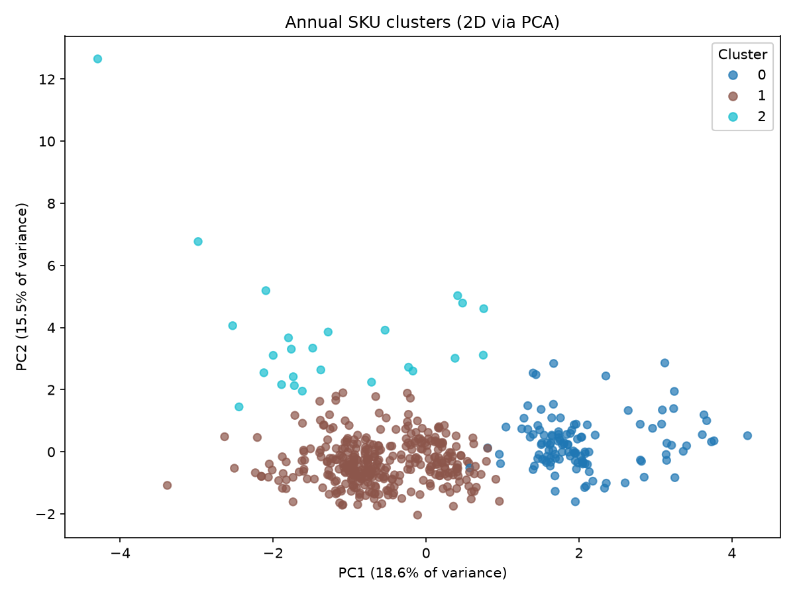

5. Caveats & Notes for the Write-Up
- “Low-Margin” naming artifact: the naming rule tags Cluster 2 “Low-Margin” because its average margin_pct (31.8%) is the lowest of the three by z-score — but the actual spread across all three clusters is only 31.8%–32.0%, essentially identical in business terms. margin_pct is also not a statistically significant cluster driver (p = 0.94, §3). Recommend noting this explicitly in the report so a reviewer doesn't read “Low-Margin” as a meaningful finding — the real story for this cluster is revenue/margin concentration and operational excellence, not thin margins.
- stockout_rate and demand_cv are borderline (p ≈ 0.06–0.07): just above the conventional 0.05 significance threshold. They're still meaningful for describing each cluster's character (e.g., the Stockout-Risk cluster does have the highest rate in absolute terms) but shouldn't be presented as statistically proven cluster drivers with the same confidence as the top four features.
- One SKU has an imputed lead time: 1 of 500 SKUs has no valid path through the plant → PDC → RDC/CDC network (likely a data gap in production or network-lane coverage) and was filled with the catalog median lead time before clustering. Worth a one-line disclosure in the methodology section; at n=1 it has no material effect on the results.
- Elasticity and shelf life are descriptive, not diagnostic, for this segmentation: both are included in the feature matrix for downstream use (pricing/promo strategy, perishability-aware policy) but neither drives the cluster split — elasticity isn't even a clustering input, and shelf_life_days is the least significant feature in the model (p = 0.86).
- This is a whole-history, single global clustering: all 52 weeks of the year are pooled into one feature value per SKU. It does not capture within-year regime changes (e.g., a SKU that was stable for 9 months then went volatile) — fine for an annual strategic segmentation, but worth stating as a scope boundary if the capstone also discusses a rolling or seasonal view elsewhere.

